Page: Fellows: The Six-day summer CHER Institute
https://www.cdrewu.edu/healthequity/cher_institute/fellows-cher-institute/
attach the PDF & word versions of CHER Institute Fellows Application Guidelines 2026

Fellows: The Six-day summer CHER Institute

The CHER Summer Institute 2026 will be held virtually June 8-13
Approximately from 9:00 AM to 4:00 PM Pacific Daylight time
The virtual Summer CHER Institute is comprised of seminars, small group science chats, mentoring activities, and networking sessions, held over Zoom with participants around the United States. The CHER Institute is designed to increase the number of early career faculty members who are better prepared to become NIH principal investigators in the field of collaborative biomedical research; with basic, clinical, or behavioral outcomes to improve health outcomes across populations. Applications are due in October to allow time for preparation of materials to be reviewed by the CHER Institute Mentors prior to the CHER Institute.
Eligibility
Required: To be selected for the program, the applicant must demonstrate that they:
- Are committed to collaborative biomedical research with basic, clinical, or behavioral outcomes to improve health outcomes across populations
- Are able to construct a two-page research prospectus for collaborative biomedical research to improve health outcomes across populations
- Have experience conducting research and publishing in peer-reviewed journals
- Are willing to sign a contract agreeing to the time commitments involved with full participation in the 6-day CHER Institute (approximately 9AM to 4PM Pacific Daylight Time), and annual data collection
Preferred: The most competitive applicants will also demonstrate:
- Experience conducting collaborative biomedical research
- History of obtaining funding for research (e.g., small or exploratory grants, including state, local, and university grants)
- Experience conducting research across populations
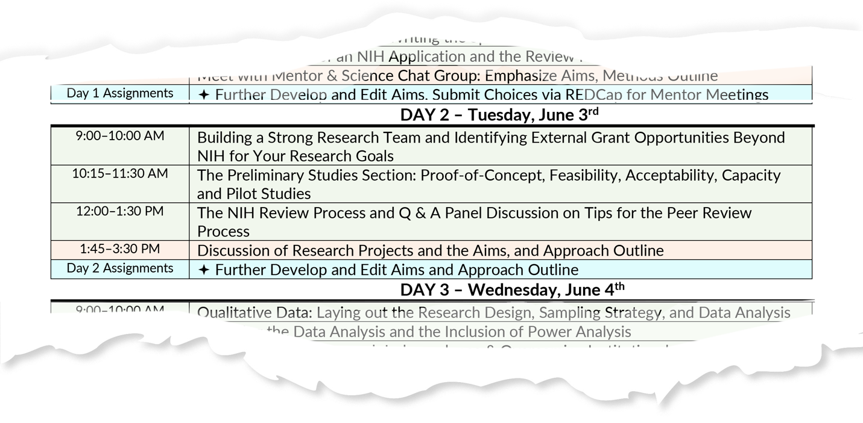
Seminar topics include:
- Overview of NIH institutes, the grant application and review process;
- Components of writing a compelling NIH grant proposal,
- Selecting the appropriate qualitative and/or quantitative method(s),
- The basics of experimental designs and avoiding methodological errors in experiments,
- Developing a data analysis plan including power analysis,
- Building relationships with faculty mentors with a strong history of NIH funding,
- Identifying and resolving common institutional challenges related to developing and submitting NIH grant applications at institutions with limited research infrastructure,
- Practical and ethical research considerations,
- Tips and strategies to consider for balancing career, professional development, and life’s journey.
Deliverables for the CHER Institute
Institute Preparation
- Submit Biographical Sketch and Photo
- Sign Media Release form
- Sign Confidentiality and Nondisclosure Agreement
- Complete Pre-Institute Assessment
- Review Videos on Grant Development
- Submit Literature Review
- Submit Draft of Professional Development Plan
- Submit Draft of Specific Aims
- Establish NCBI link
During the Institute
- Complete Daily Online Program Feedback
- Finalize Professional Development Plan
- Refine Specific Aims Page
- Develop Approach Outline for each Specific Aim
- Present on Specific Aims, Lessons Learned and Next Steps
After the Institute
- Complete Post Assessment
- Completion of CHER Institute Annual Survey and submission of CV for up to 5 years post Institute participation

Applying to the CHER Institute
There are two components to the application, to be submitted through REDCap surveys. Details on the components are provided in the CHER Institute Fellows Application Guidelines 2026 [PDF & Word links]. If you are unable to download the files, please send a request for the application to WendyNomura@cdrewu.edu. The links for the components are provided below.
- Online Application: you may leave the survey and return (with code provided in survey), though it is suggested that you be prepared to submit all documents as you complete the application: https://redcap.cdrewu.edu/surveys/?s=8RXF7KRFMNC4N448
- Two Letters of Recommendation: both letters should be submitted separately by the recommenders: https://redcap.cdrewu.edu/surveys/?s=9HDADCXJNPJRCCPK
Due Date: Application and two letters of recommendation must be submitted by October 19, 2026, at 5:00 PM Pacific Time, for the 2026 CHER Institute.

